**Taller 1 – Entrega 2**

**Documentación MER**

Asignatura: Base de datos.

Profesora: Eric Ross.

Alumnos: Brayan Maldonado

Daniel Barrios.

Fecha: 20/04/2023.

**Modelo Entidad Relación (M-E-R).**

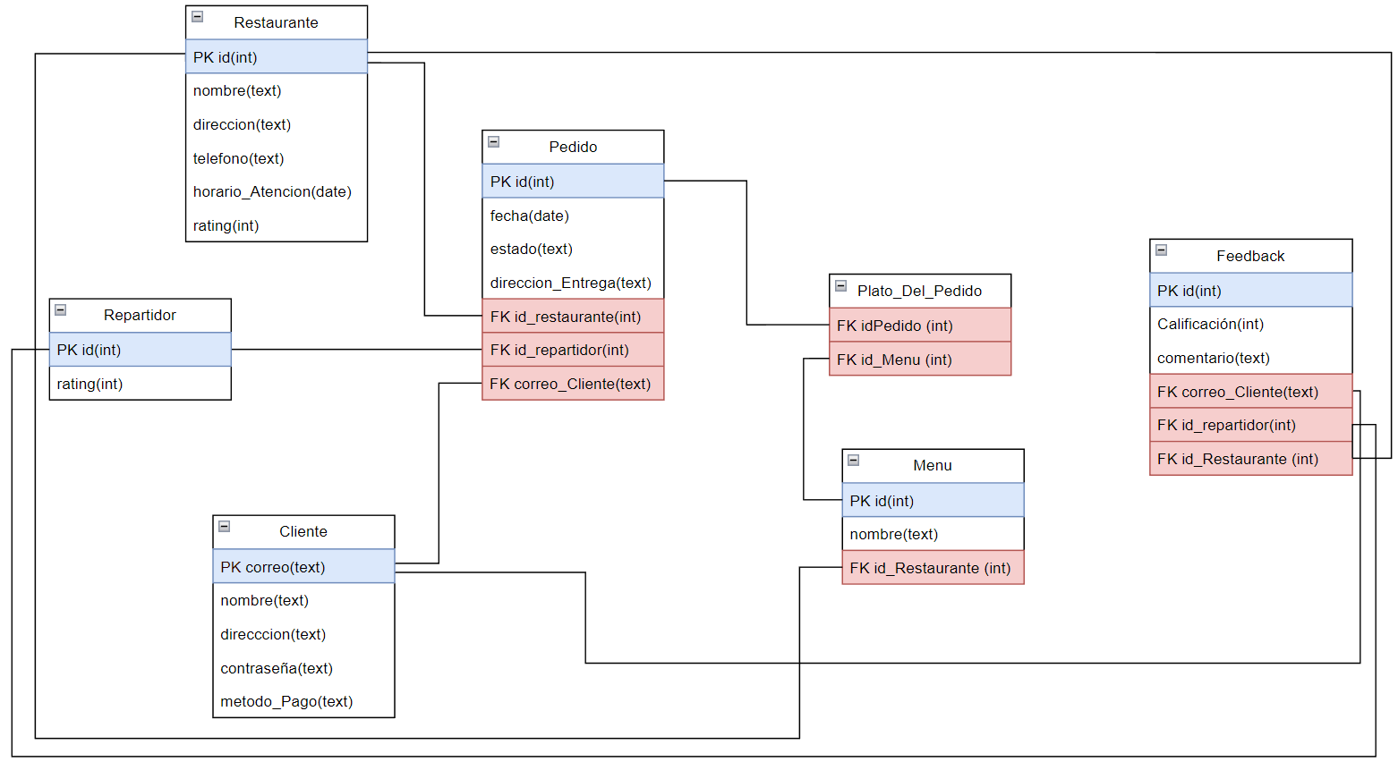

**Documentación.**

**